THINGS YOU MAY NOTICE AS YOU
DO BEMER THERAPY CONSISTENTLY:

- An enhanced general sense of well-being (even happiness)

- Better sleep & increased energy

- Increased ability to concentrate or focus

- Fewer discomforts & Less crankiness or mood changes

- An increased sensitivity to substances such as caffeine, alcohol, and sugar (your liver is working better)

- Slight changes and improvements in your food appetites & less bloating and “fluffiness”

- Better digestion and healthier “poops”

SIGNS THAT YOU ARE REMOVING
WASTE PRODUCTS FROM YOUR BLOOD

- Light headedness or dizziness
- Unexplained rashes or skin issues
- Indigestion
- A short-term increase in discomfort
These are normal bodily reactions, but if they seem like too much, do drink more water and lower the intensity level of your therapy sessions by one.

Stay on the Basic Plan or move to a lower intensity for an extra week or longer.

It is okay to go slow—go low. The more issues you have, the slower you will want to go.

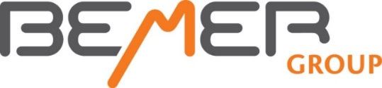
For Additional Information

If you have personal questions about your
Bemer Therapy, contact Milt or
Jamie Lee, and we’ll see if we can
help resolve the issue.

milt@manykites.com / 605 381 4842
jamie@manykites.com / 605 381 4333

If you would like to visit about purchasing
a Bemer for home use —or use with family
or another program—give us a call, and
we can go over the details for purchasing
this device or becoming a distributor for
Bemer Group.

Or visit
www.manykites.bemergroup.com
for purchasing information.

For Maximum Benefit of Bemer Therapy

Go Low and Go Slow

. . . And think good thoughts

