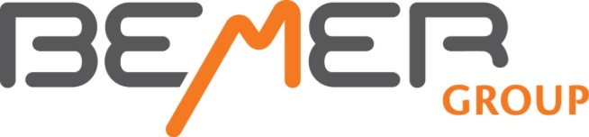

Go low—Go Slow

REMINDERS FOR BEMER USERS

- To get maximum benefit from Bemer Therapy, do two eight-minute sessions a day.

- Use the plus signal in the morning and click the plus signal off for late afternoon.

- Drink a glass of water before your session and another glass after your session. This will help your body detox gently.

- Remember that you can use the mat and another application at the same time The settings are A1 and A2 and both must be turned on. Check the image on the box to see which one you are in.

- Follow the Basic Plan—but you can use the extra applications such as the B-Spot, the B-Pad and the B-Light on areas of discomfort as often as you like. Use Intensity 1-2 for these.

- If you experience light-headedness, dizziness or any other signs of detoxi-fication, you may want to back down to a lower level of intensity for another week. Go low—go slow. And drink more water.

- This is not a quick fix—consider that for every year that you have had a condition, it may require a month or more on the Bemer to begin to enhance and restore that condition.

- Bemer Therapy cannot enhance your well-being if you don’t use it!

THINGS YOU MAY NOTICE AS YOU
DO BEMER THERAPY CONSISTENTLY:

- An enhanced general sense of well-being (even happiness)

- Better sleep

- Increased ability to concentrate or focus

- Fewer discomforts

- An increased sensitivity to substances such as caffeine, alcohol, and sugar (your liver is working better)

- Increased energy

- Less crankiness or mood changes

- Slight changes and improvements in your food appetites

- Less bloating and “fluffiness”

- Better digestion and healthier “poops”

SIGNS THAT YOU ARE REMOVING WASTE PRODUCTS FROM YOUR BLOOD

- Light headedness or dizziness
- Unexplained rashes or skin issues
- Indigestion
- A short-term increase in discomfort

These are normal bodily reactions, but if they seem like too much, do drink more water and lower the intensity level of your therapy sessions by one.

Stay on the Basic Plan or move to a lower intensity for an extra week or longer.

It is okay to go slow—go low. The more issues you have, the slower you will want to go.

For Additional Information

If you have personal questions about your Bemer Therapy, contact Milt or Jamie Lee, and we’ll see if we can help resolve the issue.

Milt 605 381 4842 Jamie 605 381 4333
milt@manykites.com jamie@manykites.com

If you would like to visit about purchasing a Bemer for home use—or use with family or another program—give us a call, and we can go over the details for purchasing this device or becoming a distributor for Bemer Group.

Or visit
www.manykites.bemergroup.com
for purchasing information.

For Maximum Benefit

of Bemer Therapy

Go Low

Go Slow

. . . And think good thoughts

